Project 10-1: Monthly Balance Calculator

User interface
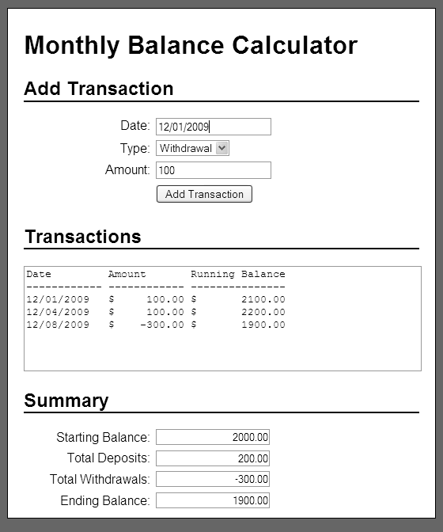

Operation
- This application allows the user to enter deposits and withdrawals for a bank account, and it calculates and displays the deposits and withdrawals with a running balance as well as the starting balance, total deposits, total withdrawals, and ending balance.

Specifications
- Store the transactions in an array of arrays.
- Use functions to organize the code for this application.
- Assume that the account will have a starting balance of 2000.
- Assume that the user will enter valid data.

